# Exercise

## Define 3 classes

* **RGB** with Properties: Red, Green, Blue of type **byte**
* **Point3D** with Properties: X, Y, Z of type **double**
* **Character** with Properties: FontSize, FontName, Text of type **string**

## Create the following window

* In the resources, create one instance of each class: RGB, Point3D, Character
* In the main area, divide the area into 3 columns
* Place a check box in each column
* Define the content of each check box to one of the objects

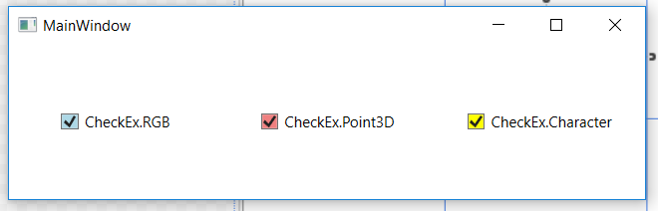

## Create Data Template for each type of content

* Make sure each data template presents all the data
* Make sure each data template is the **default** for its type
* Make sure each data template looks different

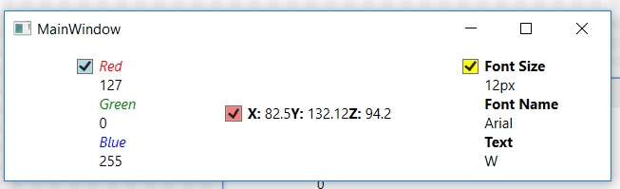

## Change the looks of the check box

* Instead of a check mark next to the content, surround it with a red circle
* Make sure the background of the circle is the background of the check box
* Make sure the red circle disappears when the check box is off